Images of our May 2021 Visit at Bear Spring Camps, Belgrade Lakes, Maine

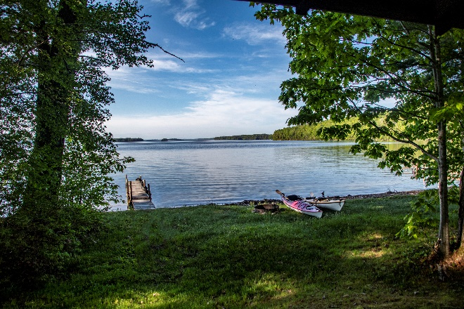As the Coronavaris panademic eases off and life begins to return to normal, the Bear Spring Camps opened again in May and there we were.  
We thoroughly enjoyed ourserlves as usual even with one of the coldest and windiest Spring weeks we have expereienced there. The dining room, housekeeping, and grounds staff were up to their usual top-notch service. The bass responded quite nicely to my ancient top-water lures and the great Meadow Stream was very navagiable. While the double digit winds made the white caps and rollers a challenge, then such challenges also can be a blast!

This photo album includes various photos of us kayaking, focusing on the Great Meadow Stream due to the windy conditions, enjoying the [sounds](https://fauxes.net/Sounds/Condo%20Sounds/BearSpringWaves-May%2025%202021%2022711%20PM.mp3) of the incoming southerly waves, and doing this and that while absorbing the wildlife and tranquility. The windy wave motion challenged our hand-held photography, but, hey, we smiled!

We had an excellent week and we are looking forward to returning in the Fall.

And for the photos, click [Bear Spring Camps, ME, - May 2021.](https://photos.app.goo.gl/A81QoFN2qfCNNQGM8) You are encouraged to “zoom in”.